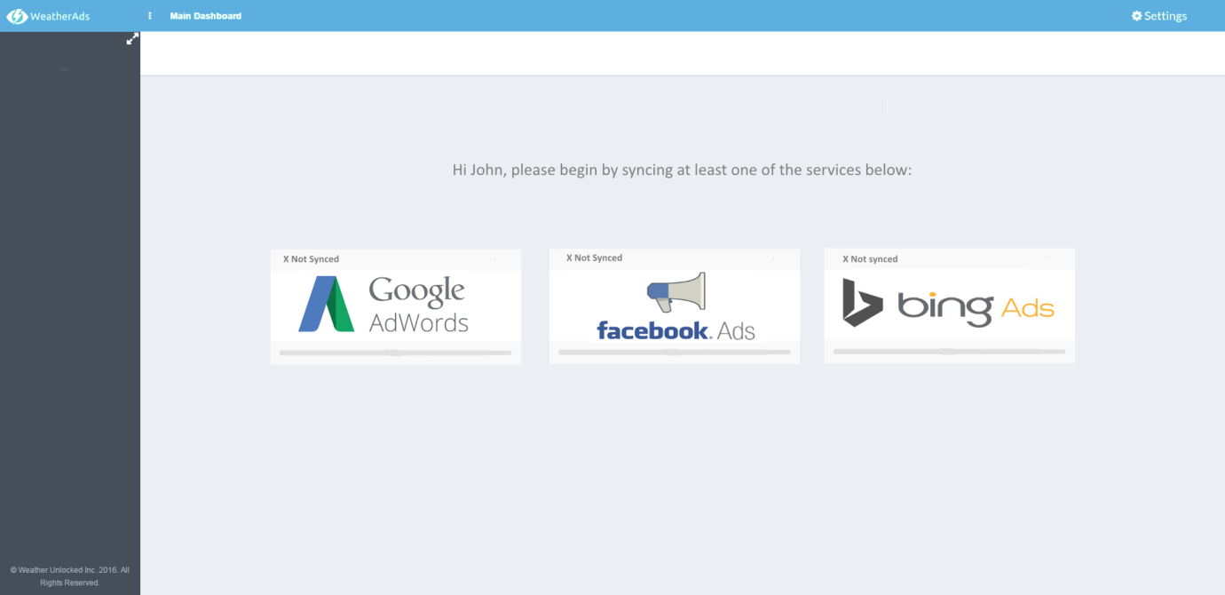

Integration widgets: <http://demo.pixelcave.com/appui/page_ui_widgets.php>

Hi John writing: #808080

Dark grey (tick) - #999999

Lighter grey - #CCCCCC

Black grey - #454E59

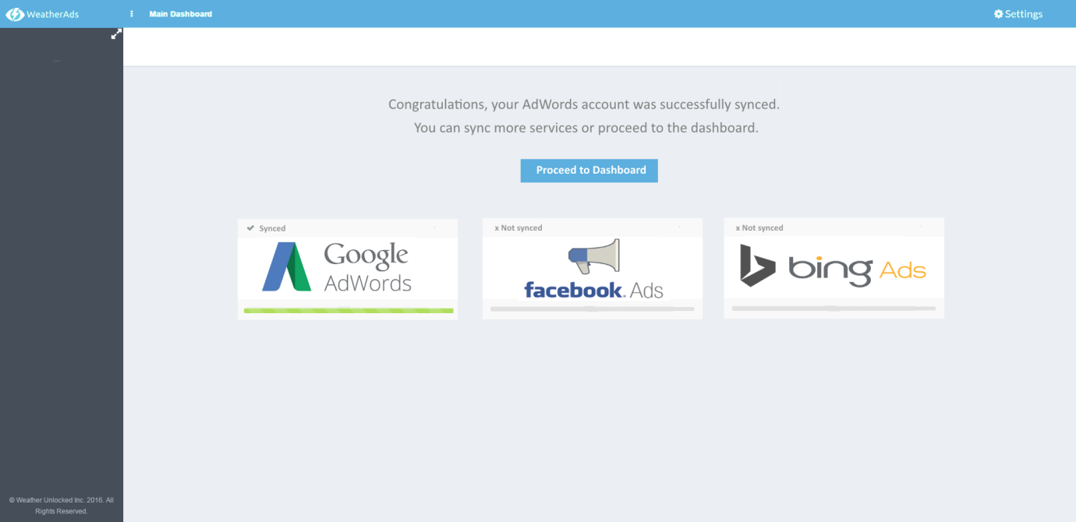

Progress bar representing synced status: <http://demo.pixelcave.com/appui/page_ui_progress_loading.php>

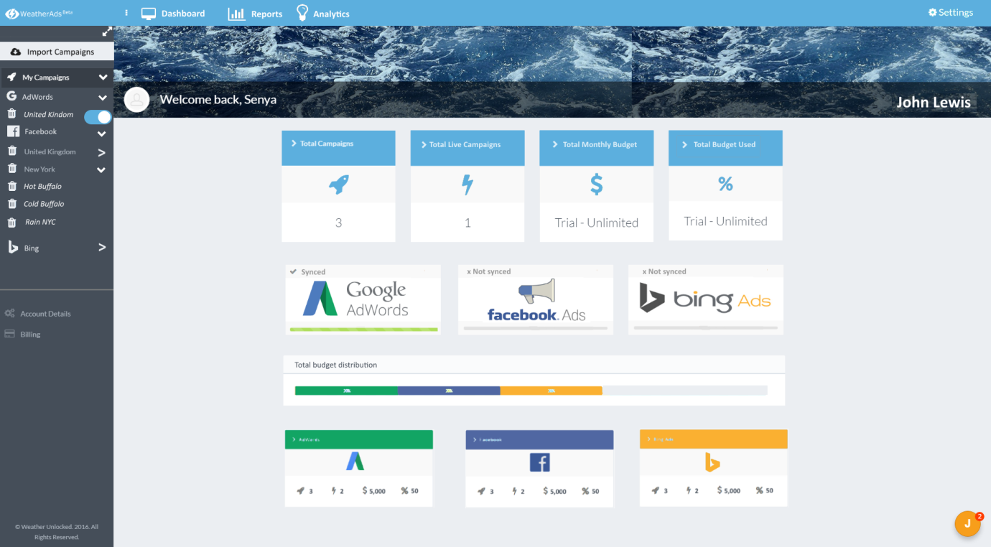

**Top bar icons:**

WeatherAds – take beta off. Not clickable link, just a logo.

Dashboard: <http://fontawesome.io/icon/desktop/>

Reports: <http://fontawesome.io/icon/bar-chart/>

Analytics: <http://fontawesome.io/icon/lightbulb-o/>

Settings: <http://fontawesome.io/icon/cog/>

**Left hand panel:**

Import campaigns: Colours/ responsiveness based on ‘friend request’ & ‘follow’ buttons here: <http://demo.pixelcave.com/appui/page_app_social.php>

Colour: #EBEEF2

**Main Screen:**

Top 4 widgets – change colour to brand blue #5CAFDE

Integration widgets – same as above page

Total budget distribution Widget: ‘Stacked’ <http://demo.pixelcave.com/appui/page_ui_progress_loading.php>

Bottom 3 modules: <http://demo.pixelcave.com/appui/page_ui_widgets.php>

Top bit:

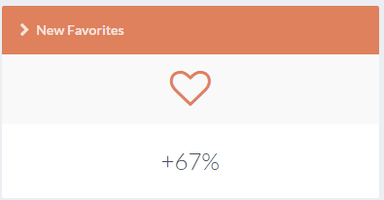

Bottom bit:



Create tooltip hoverovers for each of the icons with explanations:

Right to left: AdWords campaigns, Adwords live campaigns, total monthly budget, % of WeatherAds Plan Allowance

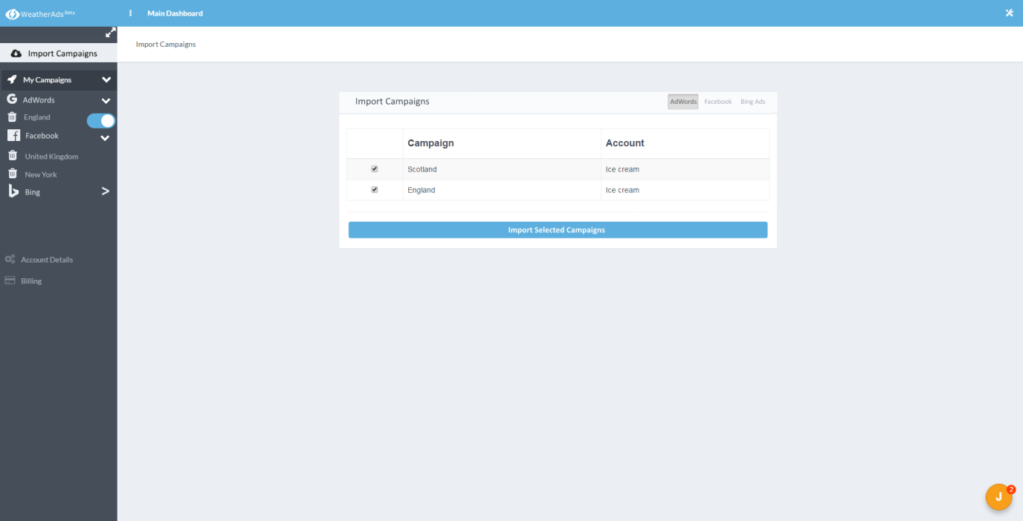

FB/ AdWords/ Bing buttons top left – taken from table here: <http://demo.pixelcave.com/appui/page_ui_tables.php>

‘Import campaign’ block button - <http://demo.pixelcave.com/appui/page_ui_buttons_dropdowns.php>

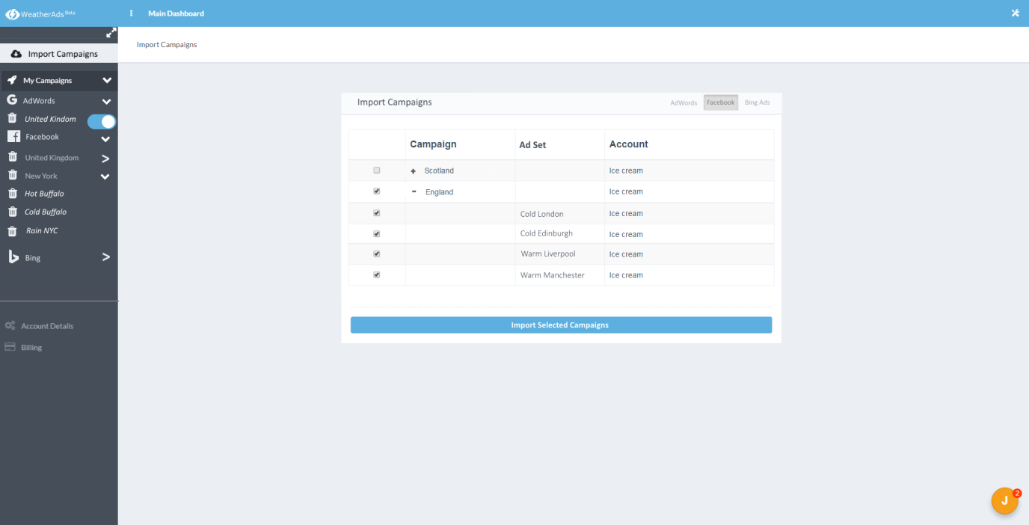

Nestable & sortable lists for FB Ad Sets: <http://demo.pixelcave.com/appui/page_comp_nestable.php>

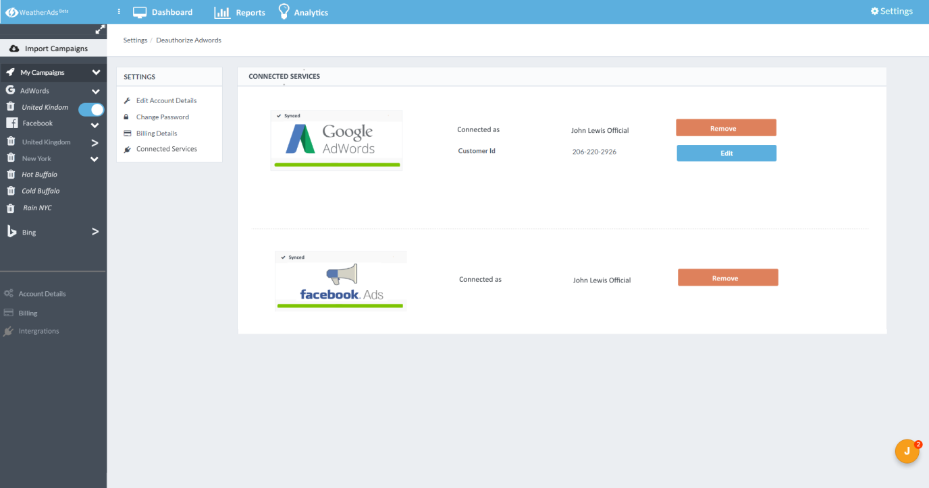

* When ‘edit’ button is pressed, screen expands down to reveal the ‘edit customer ID’ screen as it currently is on v1.0. Customer Id becomes editable. ‘Edit’ button changes to submit.

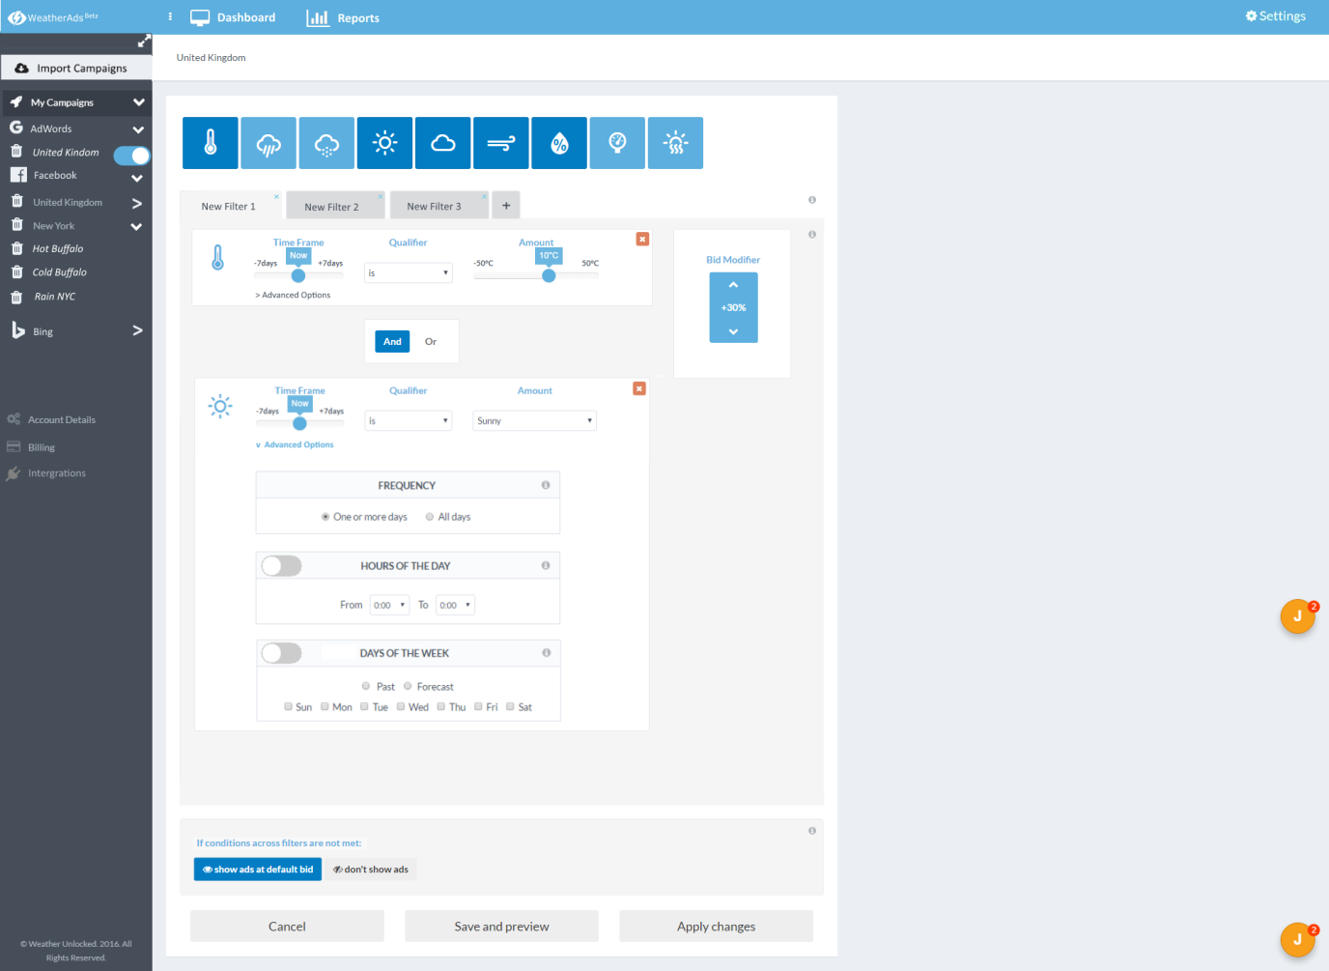

Changes made:

New filter colour (unopened) #DADBDD

Filter text writing colour: #454E59

1. Info marks - <http://demo.pixelcave.com/appui/page_ui_buttons_dropdowns.php>

Please remove the blue square hoverovers function – just an (i) that changes to a slightly greyer colour when hovered over, and then produces the message when clicked.

Red x buttons on condition options – make them smaller and square - <http://demo.pixelcave.com/appui/page_ui_tables.php>

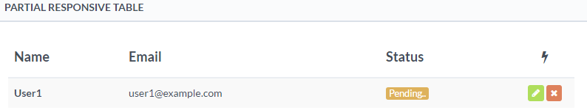

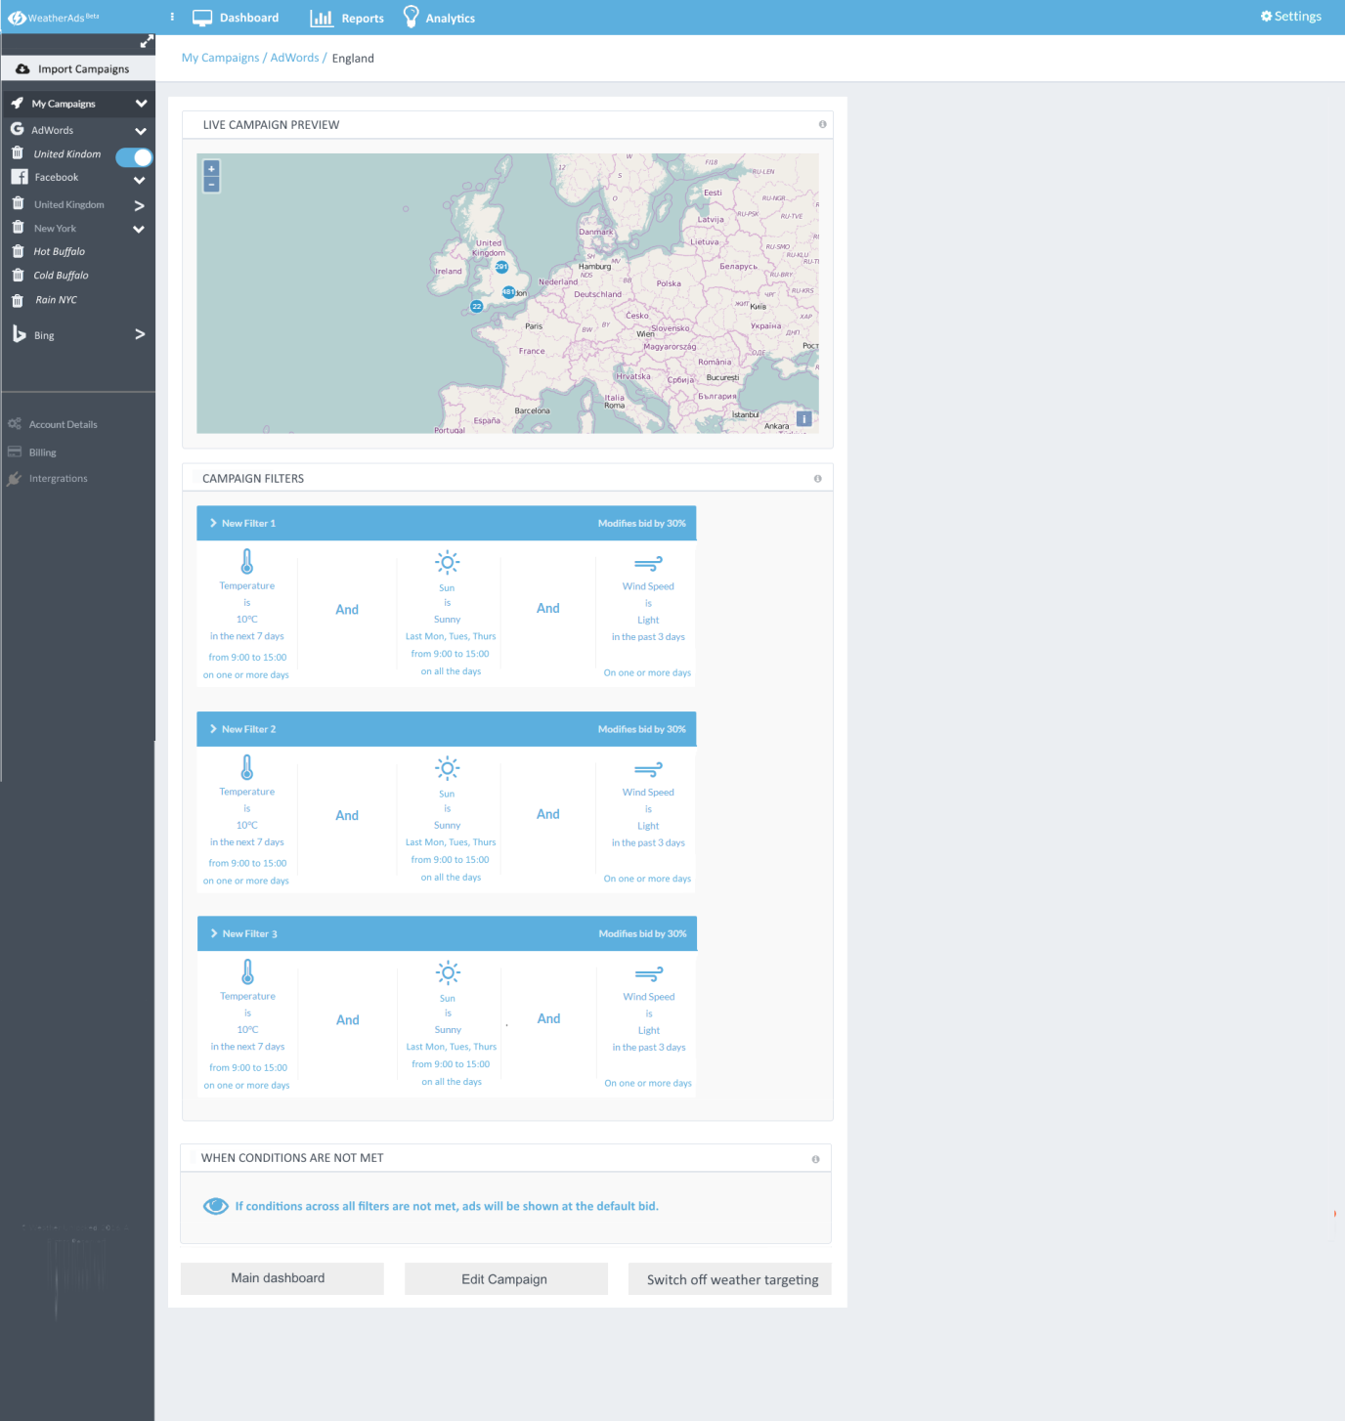

Main changes – (i) replace the question mark hoverovers as in the targeting filter screen above.

Please remove the blue square hoverovers function – just an (i) that changes to a slightly greyer colour when hovered over, and then produces the message when clicked.

When ‘acvite filters’ are previewed – please have them going across the way – 1 line per filter.

If you’re dealing with mobile devices then either use a scroller or break each filter up by individual modules and line them vertically down.

Additional block to encase the ‘when conditions are not met’ text.

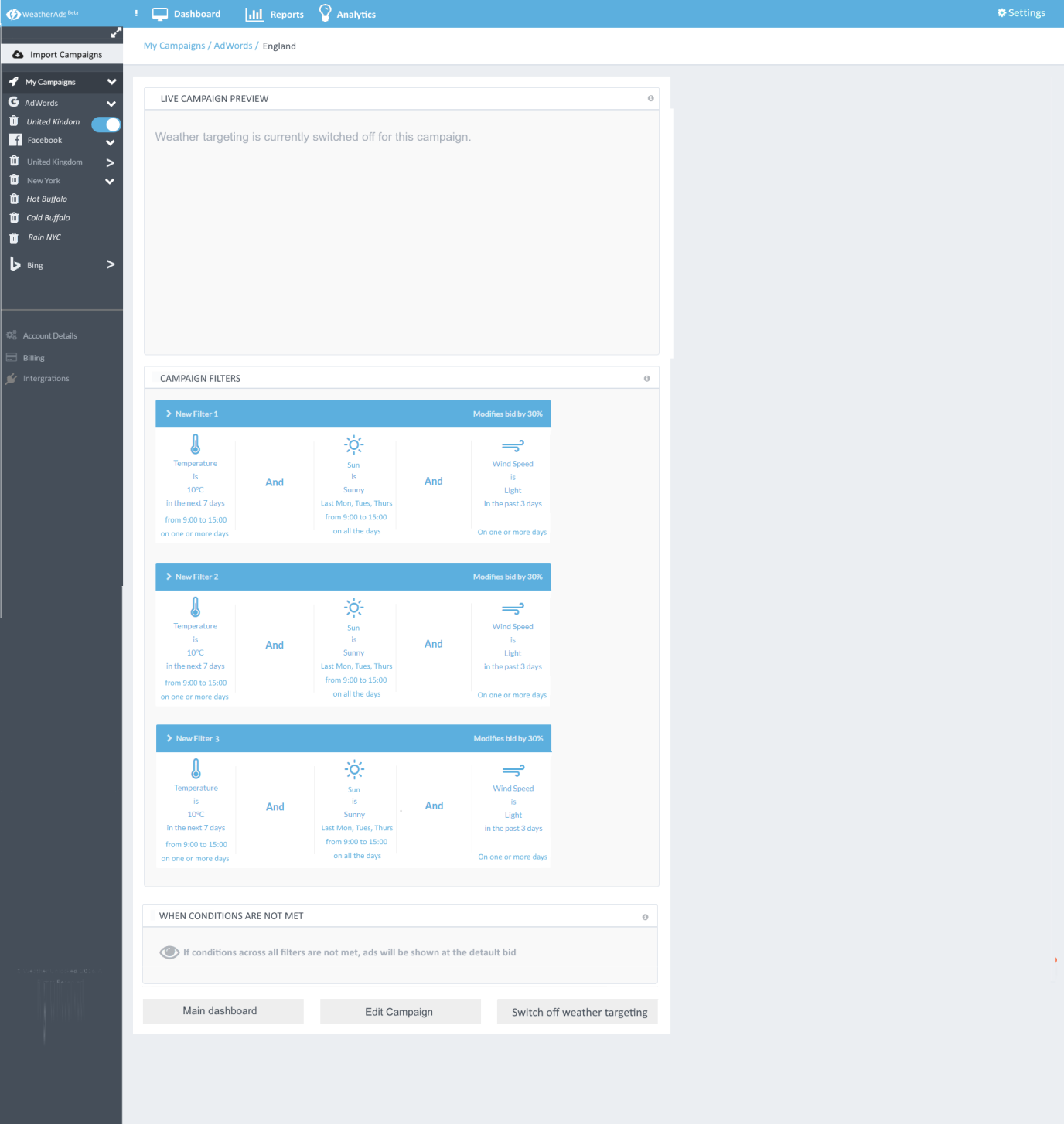

When campaign is inactive highlight the ‘condition’ text and eye logo at bottom in grey – same grey as used above in map text. See the Filter & Preview screen v2 folder for how hoverover buttons have and button logic.

Hover over button colours:

Dark Red #C43902

Dark Green #7DC402

Dark Blue #027DC4

Orange: #DE9502

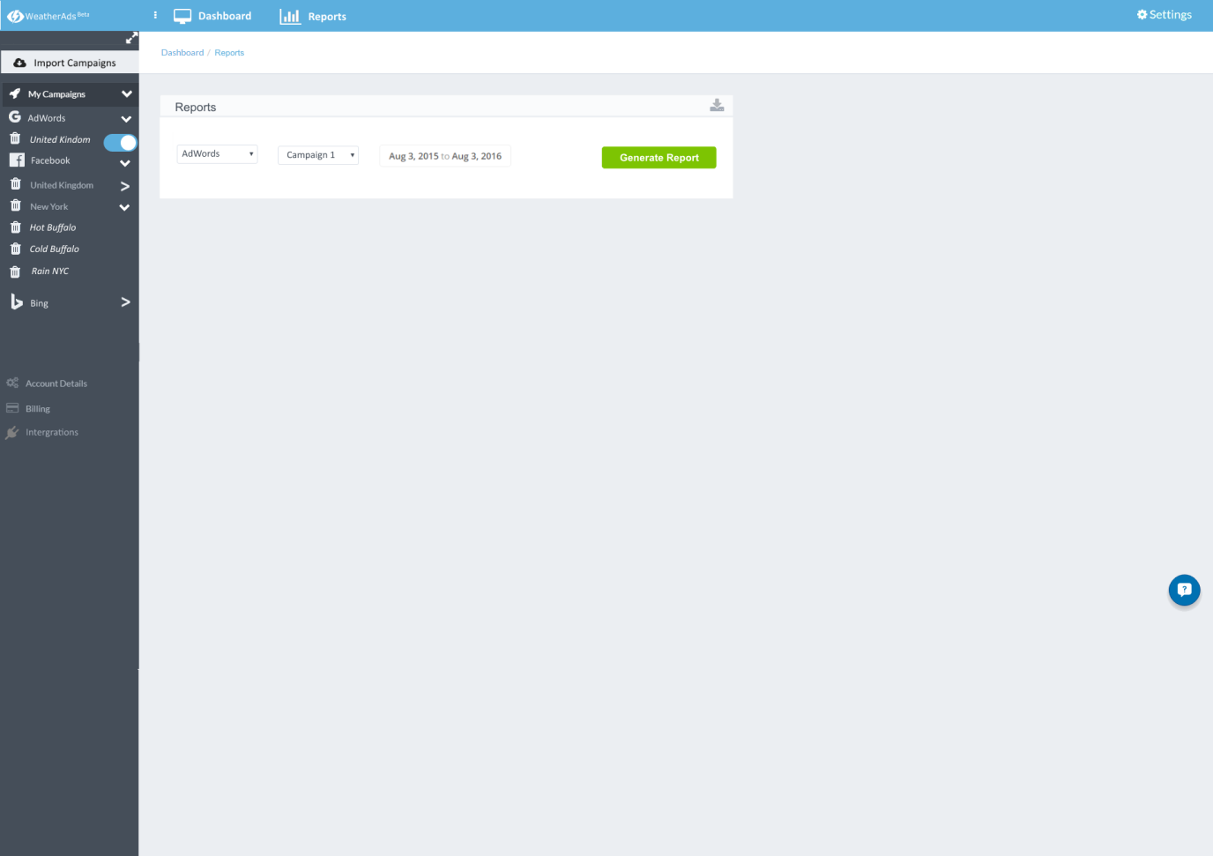

Reports:

When ‘reports’ is clicked in top menu, you get taken directly to this page. First thing you see is image above.

Top right download icon: <http://fontawesome.io/icon/download/>

Style: top left <http://demo.pixelcave.com/appui/page_ui_buttons_dropdowns.php>



Action: just saves doc to computer. Can add print functionality as well as found here: <http://demo.pixelcave.com/appui/page_ready_invoice.php>

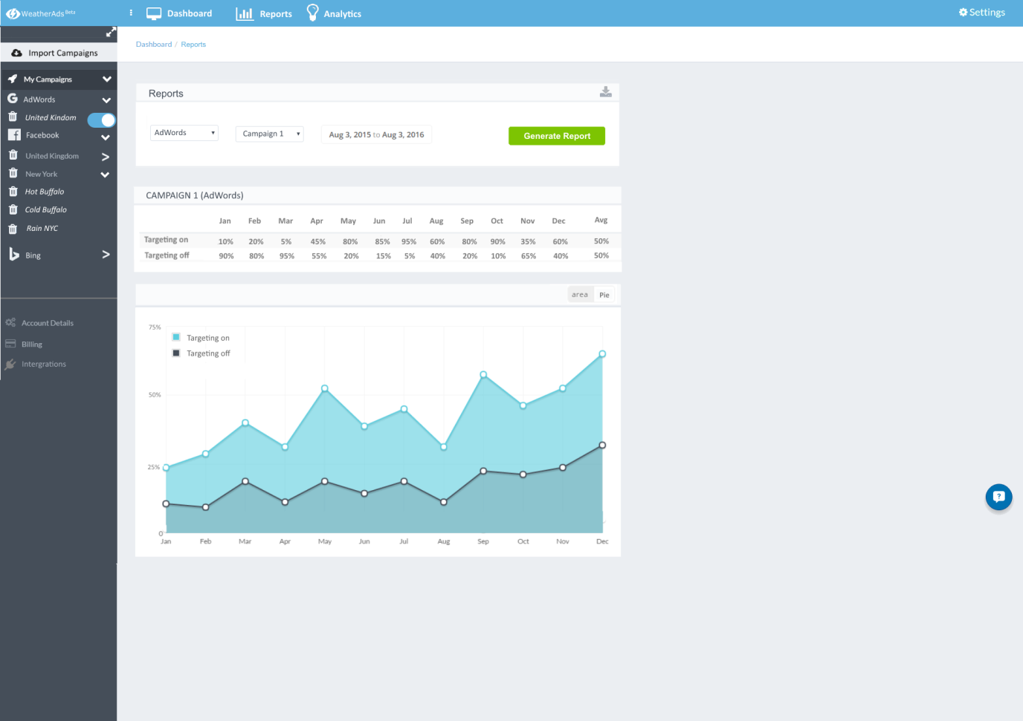

Simple table: <http://demo.pixelcave.com/appui/page_ui_tables.php>

Graphs: <http://demo.pixelcave.com/appui/page_comp_charts.php>